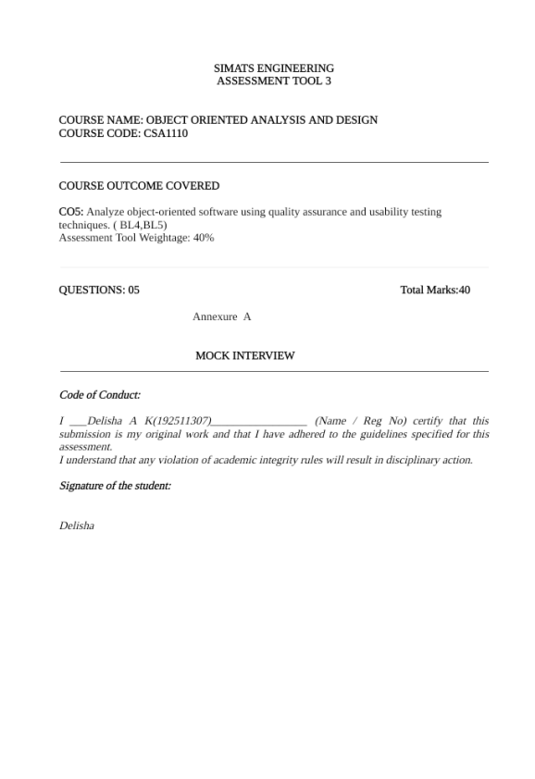
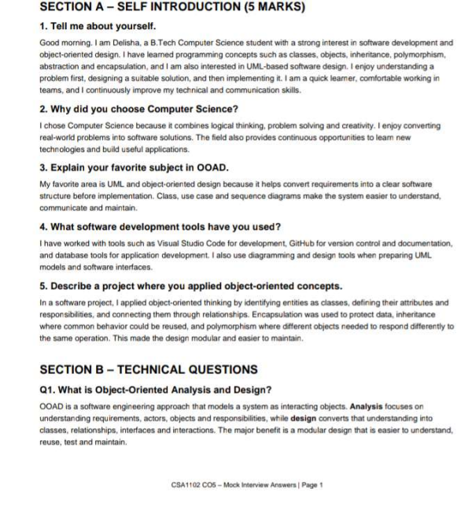
Q2. Differentiate between Analysis and Design.
Analysis: identifies what the system must do by studying requirements, users, use cases and domain objects. Design: decides how the system will do it by defining classes, methods, relationships, interfaces and interactions. In short, analysis answers what; design answers how.
Q3. Explain Encapsulation with an example.
Encapsulation means bundling data and the methods that operate on it inside a class and controlling direct access to the data. For example, a BankAccount can keep balance private and provide deposit() and withdraw() methods. This prevents invalid direct changes and protects the object's state.
Q4. What is Inheritance? Mention its types.
Inheritance allows a child class to acquire common attributes and behavior from a parent class. For example, Doctor and Nurse can inherit common details from Staff. Common forms are single, multilevel, hierarchical and multiple inheritance. In Java, multiple inheritance of classes is not supported, but multiple interfaces can be implemented.
Q5. Define Polymorphism and its benefits.
Polymorphism means one interface or method call can represent different behaviors depending on the object. For example, a pay() operation can behave differently for CardPayment and UpiPayment. It improves flexibility, extensibility and maintainability because new implementations can be added with less change to existing client code.
Q6. What is Abstraction?
Abstraction hides unnecessary implementation details and exposes only the essential features. For example, a user can call makePayment() without knowing the internal validation and transaction processing. In object-oriented design, abstraction can be achieved using interfaces and abstract classes.
Q7. Difference between Aggregation and Composition.
Aggregation is a weak whole-part relationship where the part can exist independently. Example: Department and Professor. Composition is a strong whole-part relationship where the part's lifecycle depends on the whole. Example: House and Room. If the whole is destroyed, its composed parts are normally destroyed as well.
Q8. What is Coupling and Cohesion?
Coupling is the degree of dependency between modules; low coupling is preferred because changes in one module have less effect on others. Cohesion measures how closely related the responsibilities inside one module are; high cohesion is preferred. Good OO design aims for low coupling and high cohesion.
Q9. What is a Class and an Object?
A class is a blueprint that defines attributes and behaviors. An object is a runtime instance of that class. For example, Car can be a class with color and speed, while myCar is an object created from it.
Q10. Explain Object Responsibility.
Object responsibility means the work an object is expected to perform or the information it is expected to know. Responsibilities should be assigned to the class that has the required information or behavior. Clear responsibilities improve cohesion, reduce unnecessary dependencies and make the design easier to maintain.
SECTION C – UML MODELING (15 MARKS)
Q11. What is UML?
UML, or Unified Modeling Language, is a standard visual language used to specify, visualize, construct and document software systems. It provides diagrams such as use case, class, sequence, activity, state, component and deployment diagrams.
CSA1102 CO5 – Mock Interview Answers | Page 2
Q12. When would you use a Use Case Diagram?
A use case diagram is used during requirements analysis to show system functionality from the user's perspective. It identifies actors, use cases and their relationships. For example, in a hospital system, Patient can be an actor who books an appointment.
Q13. Draw and explain a Class Diagram for a Library Management System.
A suitable simple model is: Library contains Books; a Member borrows Books through a Loan. Librarian manages books and members. Suggested classes are Library, Book, Member, Librarian and Loan. Typical relationships are: Library–Book (1 to many), Member–Loan (1 to many), Book–Loan (1 to many over time), and Librarian–Library (manages).
Q14. Differentiate Sequence Diagram and Activity Diagram.
A Sequence Diagram focuses on the time-ordered messages exchanged between objects for a scenario. An Activity Diagram focuses on the workflow of activities, decisions and parallel processes. Therefore, sequence diagrams emphasize object interaction, while activity diagrams emphasize process flow.
Q15. Explain State Diagram with an example.
A state diagram represents the different states of an object and the events that cause transitions. For an Order, states may be Created → Confirmed → Shipped → Delivered. If the customer cancels before shipping, the order can transition to Cancelled. This is useful when an object's behavior depends strongly on its current state.
Q16. What is a Deployment Diagram?
A deployment diagram shows the physical arrangement of hardware or execution nodes and the software artifacts deployed on them. For example, a web system can show a user's device connected to a web/application server, which connects to a database server.
Q17. How do Component Diagrams help software architects?
Component diagrams show the major software components and their dependencies or provided/required interfaces. They help architects divide a system into manageable modules, understand dependencies, support reuse, and evaluate whether the architecture is loosely coupled and maintainable.
Q18. What is Multiplicity in UML?
Multiplicity specifies how many instances of one class can be associated with another. Common notations include 1, 0..1, 1..* and 0..*. For example, one Customer may place zero or many Orders, represented as Customer 1 — 0..* Order.
SECTION D – CASE STUDY / PROBLEM SOLVING (10 MARKS)
CSA1102 CO5 – Mock Interview Answers | Page 3
Case Study 1 – Hospital Management System
1. Classes: Patient, Doctor, Appointment and Bill. Additional classes such as Receptionist or Department can be introduced if required by the system scope.
2. Simple class structure: Patient 1 — 0..* Appointment; Doctor 1 — 0..* Appointment; Appointment 1 — 0..1 Bill. Patient can have multiple appointments, and a doctor can handle multiple appointments.
3. Relationships: Patient and Doctor are associated through Appointment. Appointment is associated with Billing/Bill because the appointment may generate a bill.
4. UML diagrams: Use Case Diagram for requirements and actors; Class Diagram for static structure; Sequence Diagram for appointment booking or billing interaction; Activity Diagram for workflows such as patient registration; State Diagram for appointment states such as Scheduled, Completed and Cancelled.
5. Inheritance: A general Person class can contain common attributes such as name and contact details. Patient and Doctor can inherit from Person. If the system requires different staff types, Staff can be further specialized into Doctor, Nurse and Receptionist.
Case Study 2 – Online Shopping System
1. Actors and use cases: Customer is the main actor. Admin and Payment Service can also be actors depending on system scope. Customer use cases include Browse Products, Add to Cart, Place Order, Make Payment and Track Order. Admin may Manage Products and Manage Orders.
2. Use case structure: Customer → Browse Products, Add to Cart, Place Order, Make Payment, Track Order. Admin → Manage Products, Manage Orders. Place Order can include checkout/payment activities.
3. Suitable design patterns: Strategy Pattern is suitable for different payment methods; Factory Method can create appropriate payment processors; Observer can be considered for order-status notifications. The exact choice should depend on the system requirements.
4. Polymorphism in payment processing: Define a common Payment interface with a method such as pay(). CardPayment, UpiPayment and NetBankingPayment can implement it differently. The checkout module can call payment.pay() without depending on the concrete payment type. This reduces coupling and makes adding a new payment method easier.
SECTION E – HR & PROFESSIONAL QUESTIONS (5 MARKS) Q19. Why should we hire you?
You should hire me because I combine a strong foundation in Computer Science with a willingness to learn and improve. I approach problems logically, communicate clearly and take responsibility for my work. I can understand requirements, apply object-oriented concepts and work collaboratively to deliver practical solutions.
Q20. What are your strengths and weaknesses?
My strengths are problem solving, quick learning, consistency and teamwork. One area I am improving is spending too much time trying to perfect a solution. I am addressing this by prioritizing tasks, setting time limits and focusing first on a correct, maintainable solution.
Q21. How do you handle project deadlines?
I first break the project into smaller tasks, identify priorities and estimate the time required. I track progress regularly and complete critical tasks first. If I face a blocker, I communicate it early and look for an alternative instead of waiting until the deadline.
CSA1102 CO5 – Mock Interview Answers | Page 4
Q22. Have you worked in a team project? Explain your role.
Yes. In team projects, I contribute to planning, implementation, testing and documentation based on the assigned module. I make sure my work integrates correctly with other members' modules, communicate issues early and help the team maintain a consistent final solution.
Q23. Where do you see yourself in five years?
In five years, I see myself as a skilled software professional who can design and develop reliable applications and contribute to larger projects. I want to strengthen my expertise in software architecture, object-oriented design and modern development practices while taking greater responsibility within a team.
CSA1102 CO5 – Mock Interview Answers | Page 5
